Instructions for Saving a Word document as an Accessible PDF
- Open an Accessible Word document.

- Go to “File” and select “Save As”

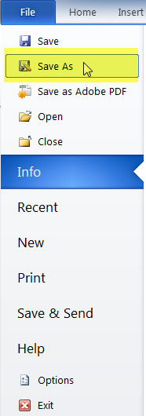

- Under the File name in the area labeled “Save as type” select PDF

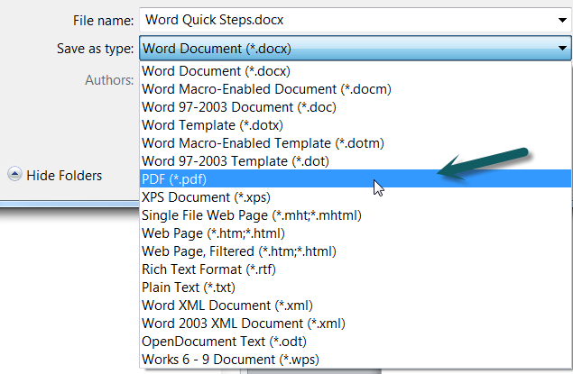

- Select “Options”

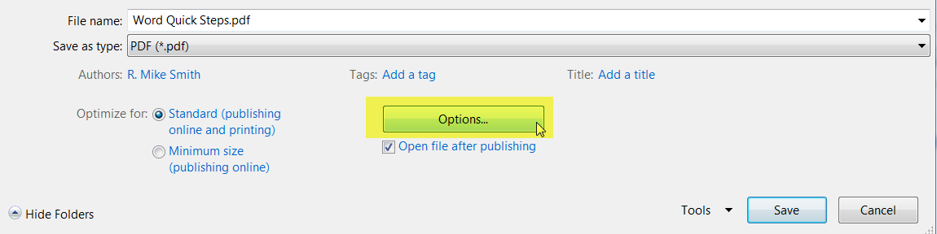

- Under the section, labeled “Include non-printing information” ensure that “Create bookmarks using “Headings” is selected.

- Ensure that the check boxes, titled “Document Properties” and “Document Structure tags for accessibility”, are selected. This will help screen readers identify the heading levels and read it correctly for end users.

- Click on OK

