Sunshiny PowerPoints
October 2016

Master Slide
- To provide a consistent presentation theme
- To establish the author/presenter; to include course information (course name & number, instructor name, presentation name & number) OR presentation information (presentation title; presenter name, affiliation, contact information)
- To simplify content
*Refer to Microsoft Office Support’s What is a Slide Master?

Outline
- To provide an alternative audience’s copy of presentation
  - To provide a text-based version of presentation
- To verify order of presentation
* Refer to Microsoft Office Support’s Show or Hide the Outline or Slides Tab

Notes
- To include presentation script, planned activities, transitions, references & resources
- To provide a presenter’s copy of presentation
- To use as a guide during presentation
* Refer to Microsoft Office Support’s Create & Print Notes Page
* Refer to Microsoft Office Support’s Presenter View

Master Slide
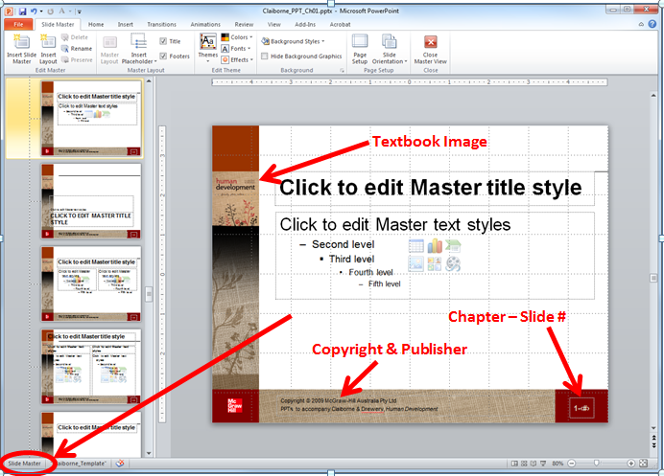

- What items are unique to the Slide Master?

Outline
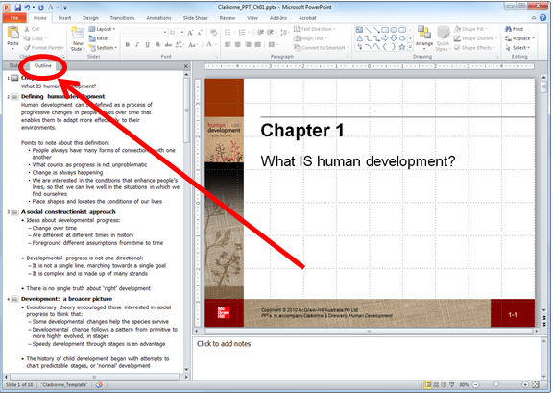

- Click to change from slide view to outline view.
- Verify the outline order of the current slide.

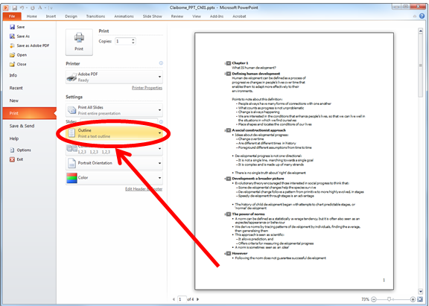

- Before printing, click on File, then Print, and then select Outline.
- On the right is the print preview. Check that outline is showing.

Notes
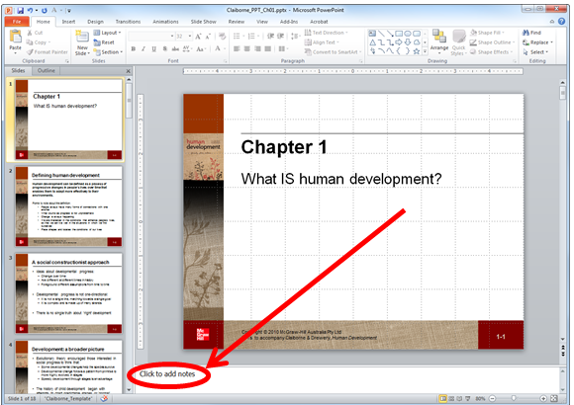

- Follow these directions, click to add notes.
- Type in an adjective that describes human development.

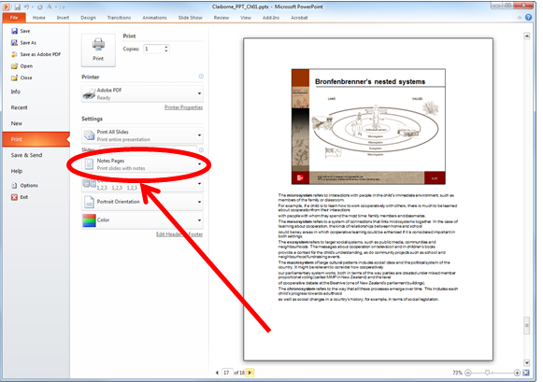

- Before printing, click on File, then Print, and then select Notes Pages.
- On the right is the print preview. Check that your note is included on the appropriate slide.

Presenter View
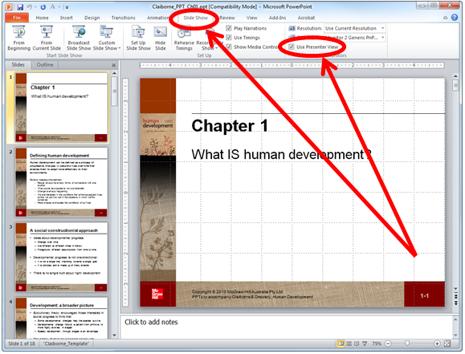

- Click on Slide Show and check Use Presenter View.

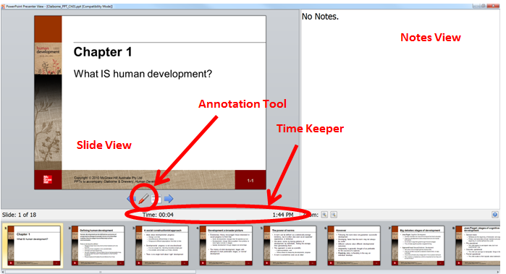

- Start slideshow to see this (full screen) view.
- Test out the annotation tool!

