Making a PDF Document Accessible Using Adobe Acrobat DC
Adobe Acrobat DC is used to Save PDF documents as accessible Word documents. If the PDF cannot be converted to an accessible Word document format, it is Saved as an Editable PDF. Use the steps below to Save a PDF document as a Word document or as an Editable PDF document.
- Open the PDF in Adobe Acrobat DC.
- Click on Accessibility to run the Accessibility Checker. If the word Accessibility does not appear in the menu to the right, type Accessibility in the Search box.

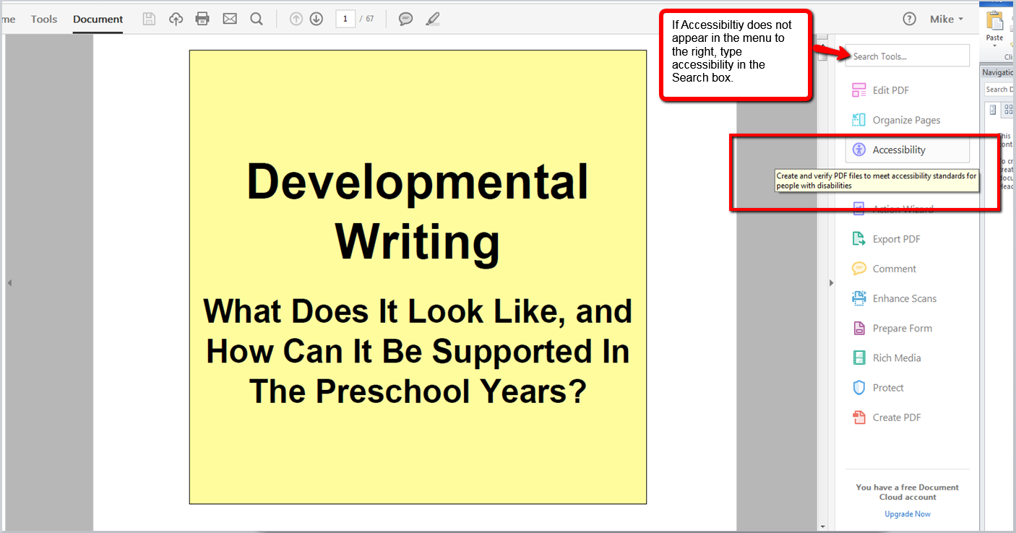
- In the Accessibility menu, select Full Check.
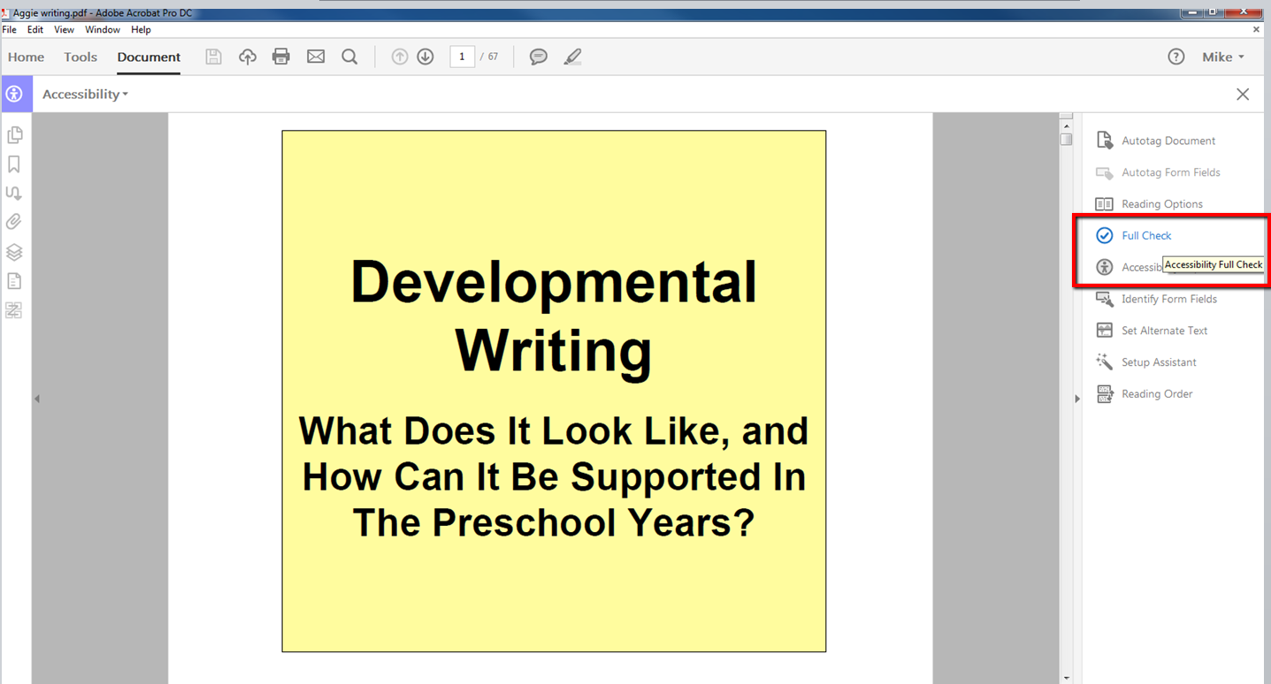

- When the Checker opens click Start Checking.
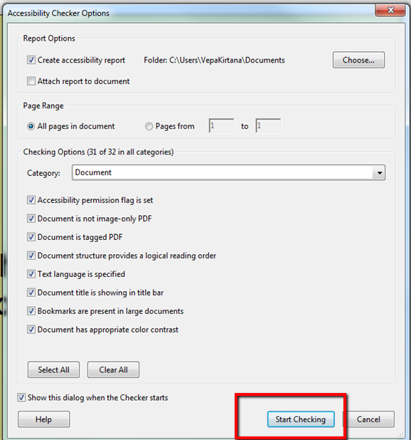
- The Accessibility Report will appear on the left side of the screen. Click on each item in the report that does not have a green check. In the menu that appears, select Pass, after verifying item visually.

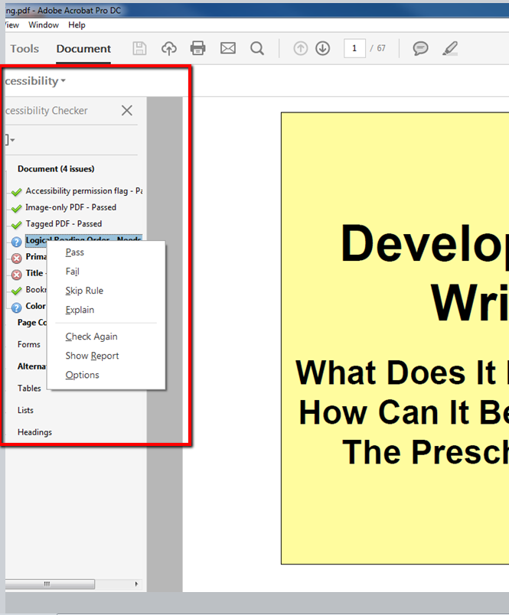
- A green check mark appears next to the item corrected. Click on the next item in the report. Click on Fix in the menu that appears.
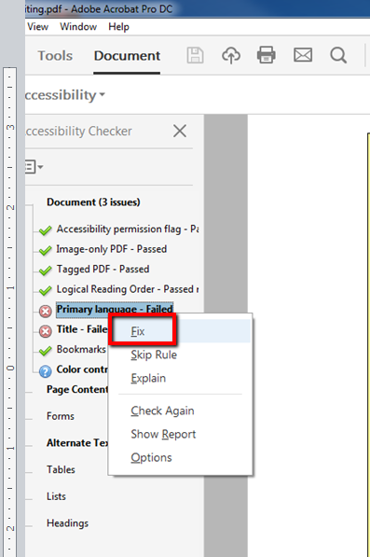
- Select English, and then click OK.
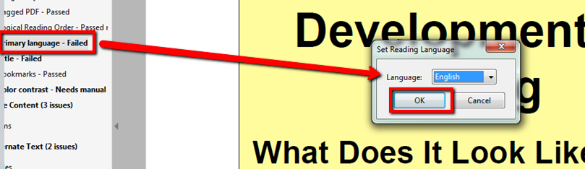

- When all items on the report have been cleared, click on File, Export To, Microsoft Word, then Word Document.
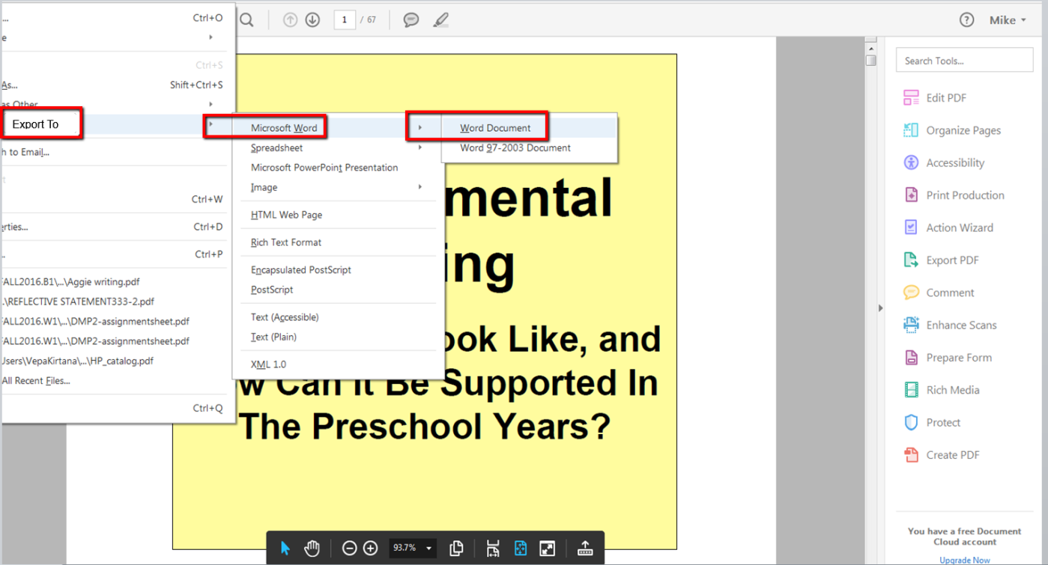
- Refer to the Instructions for Making a Word Document Accessible.

- If the font is too large or not readable, click the Clear Formatting button.
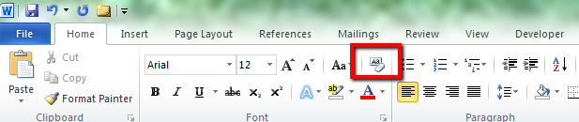
- If issues are encountered open the PDF in Adobe Acrobat DC and Save the PDF as an Editable PDF.
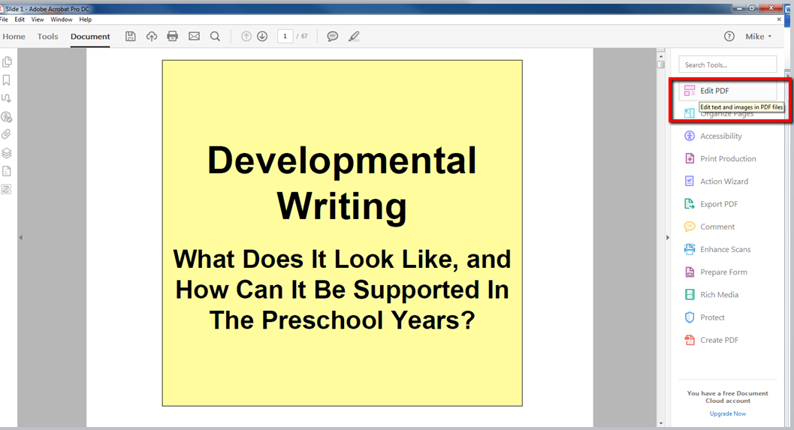

- Check for contrast and change font color if needed.
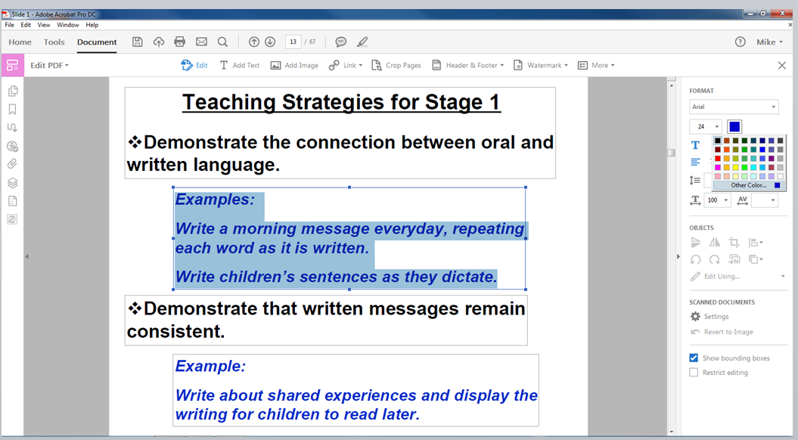
- If text is not accessible, enter descriptive text or alt text.

- Add alt text or descriptive text to all images, charts, and graphs in the document.
- Contact Accessibility Lead, petra.strassberg@tamuc.edu, if you have any questions.

